Other DB Objects (View, Synonyms, Index & Sequence) :

Problem
Schema Diagram for Electricity_Reading

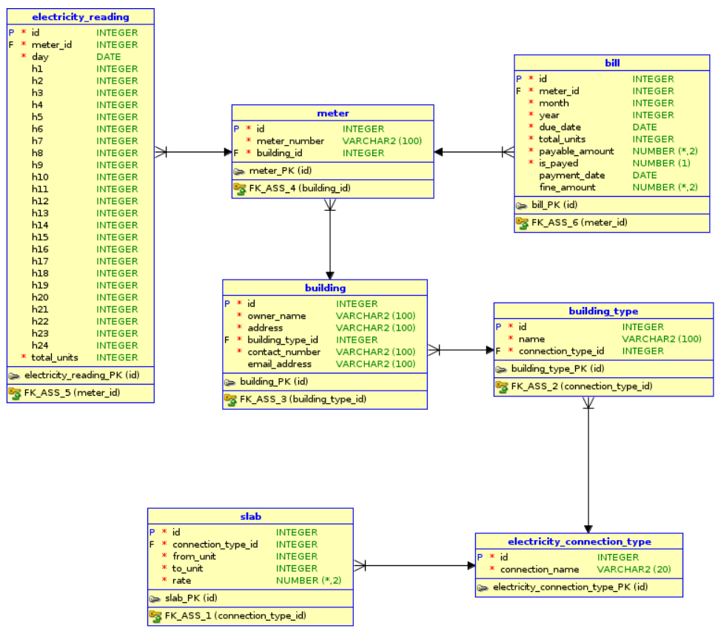

Q 1. Create a view named 'building_details' to display all the details of building.
Ans :
CREATE VIEW building_details AS SELECT * FROM building;

Q 2. Write a query to create synonym electricity_bill for table bill.
Ans :
CREATE synonym electricity_bill for bill;

Q 3. Create an UNIQUE index building_idx for owner_name for the table building.
Ans :
CREATE UNIQUE INDEX building_idx ON building(owner_name);

Assess :

Problem
Schema Diagram for Metro Station

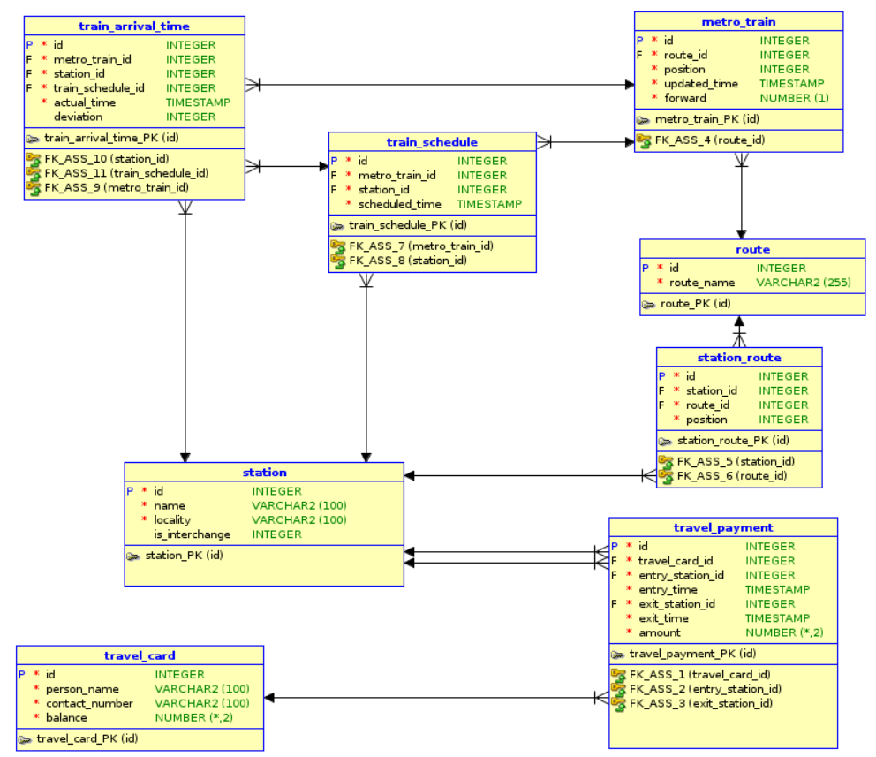

Q 1. Create a view named 'travel_card_details' to display all the details of travel_card.
Ans :
CREATE VIEW travel_card_details AS SELECT * FROM travel_card;

Q 2. Write a query to create synonym owner_detail for table building.
Ans :
CREATE synonym owner_detail for building;

Q 3. Create an index due_datex for due_date for the table bill.
Ans :
CREATE INDEX due_index ON bill(due_date);

